Amazon Web Services

Managing EC2 Instances

Contents

Creating EC2 instances 4

Choose AMI 5

Select the instance type 7

Configure Instance 7

The instance can be created in any subnet or availability zone. 8

Adding volumes 10

Adding Tags 11

Create security groups 12

Review 12

Creating Keypair 13

EC2 metadata 16

Description 16

Status Checks 16

Monitoring 17

Tags 17

Usage Instructions 18

Changing the size of EC2 instance 20

Security groups 23

Create new security group 23

Adding Rules 25

Attaching security group to EC2 26

Creating AMI 29

Login to AWS Console

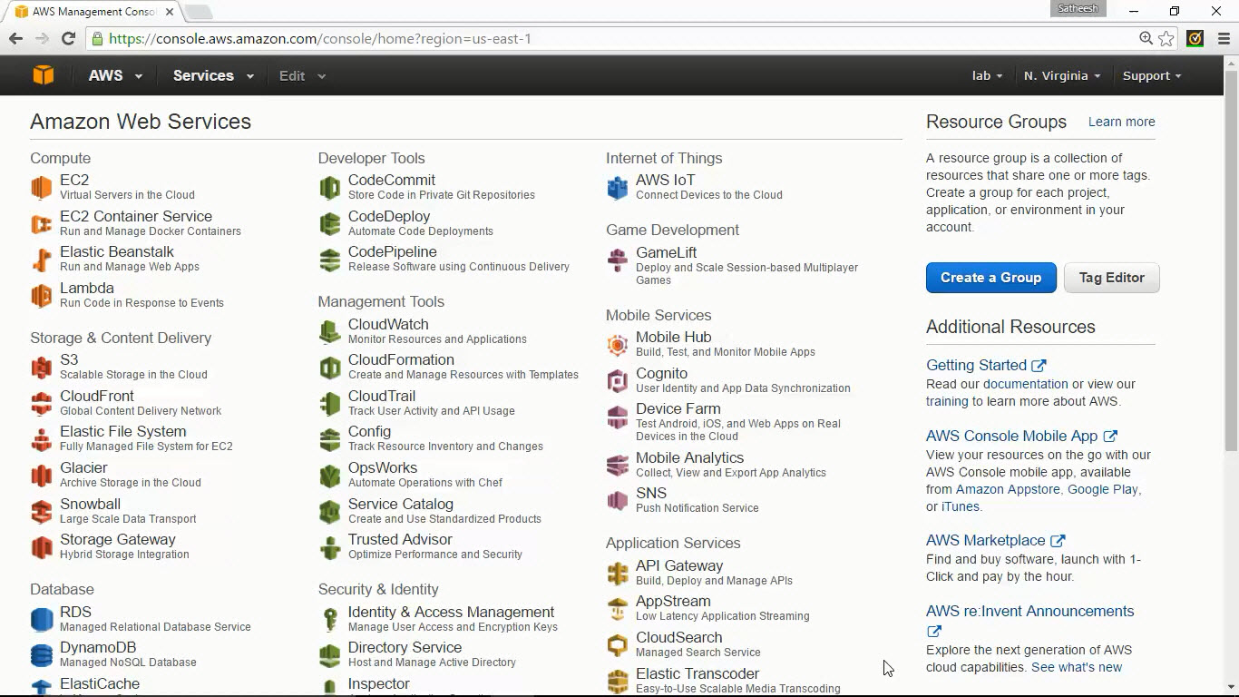

# Creating EC2 instances

Click on EC2 and go to EC2 dashboard.

This shows the summary of EC2 resource you have in the region. Click on running instances to see the running instances.

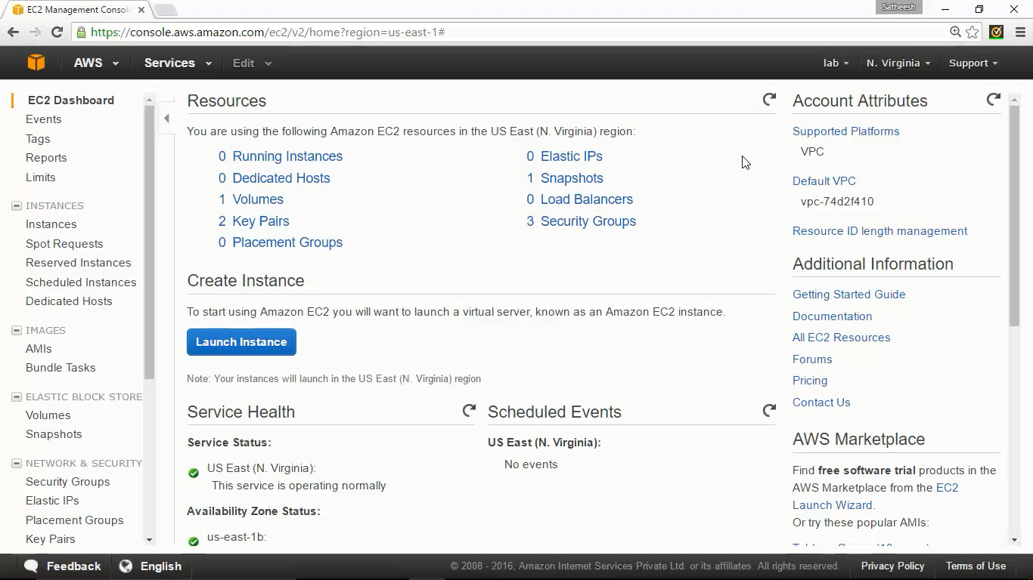

Click on Launch Instance to create a new instance. This will take you to the EC2 instance creation wizard which includes multiple steps choosing AMI, instance type etc,.

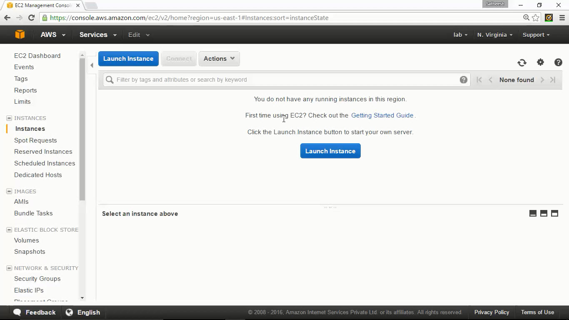

## Choose AMI

You can choose AMI from AWS marketplace, community. If you have a customized AMI build as per your requirement you can also choose it to build instance.

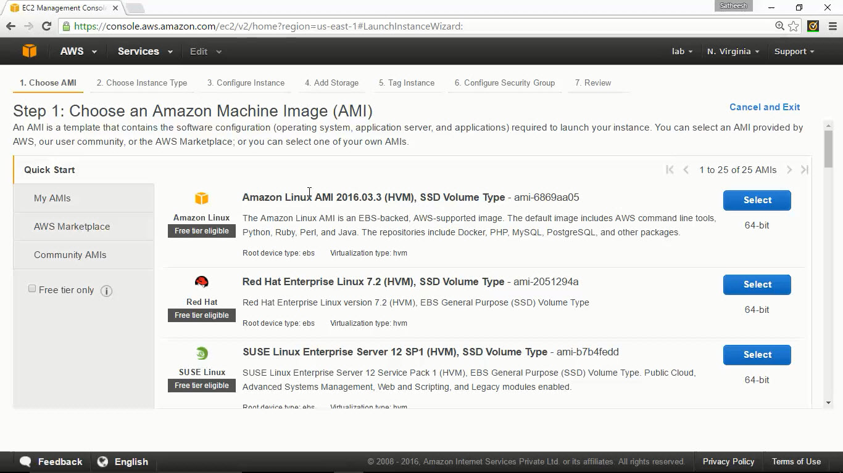

Click on AWS marketplace to choose the AMIs from marketplace.

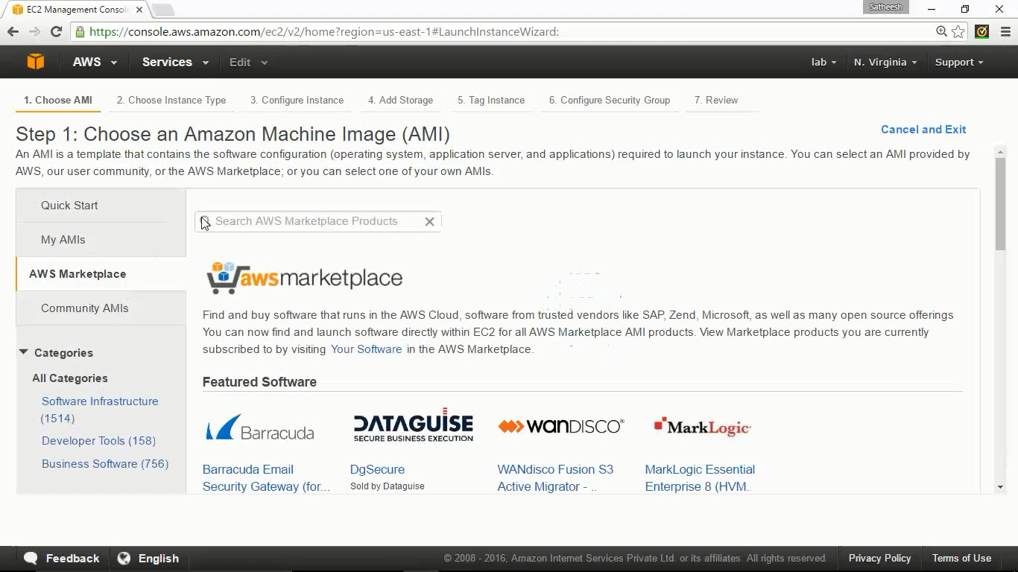

Let us create an EC2 instance with CentOS for this exercise. Type in centos and click on enter. It would display the CentOS images available in the AWS marketplace.

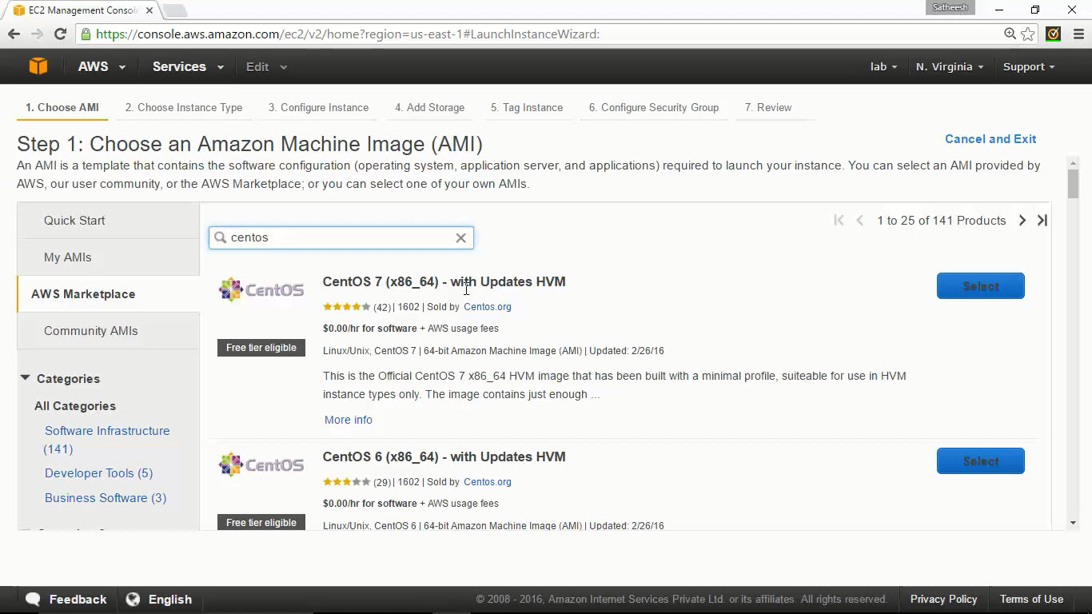

## Select the instance type

You can pick any size per the requirement. This can also be changed at any point of time later.

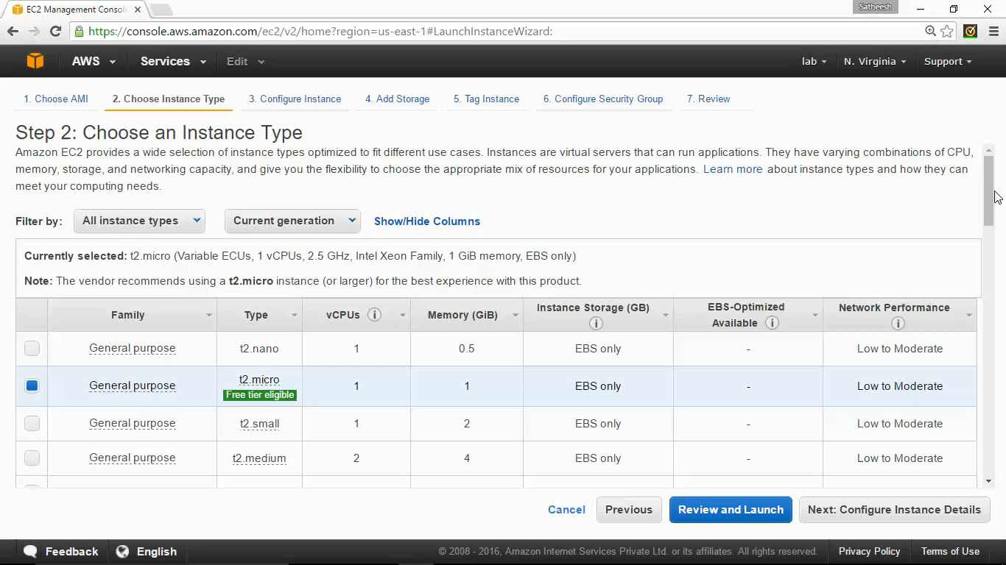

Configure Instance

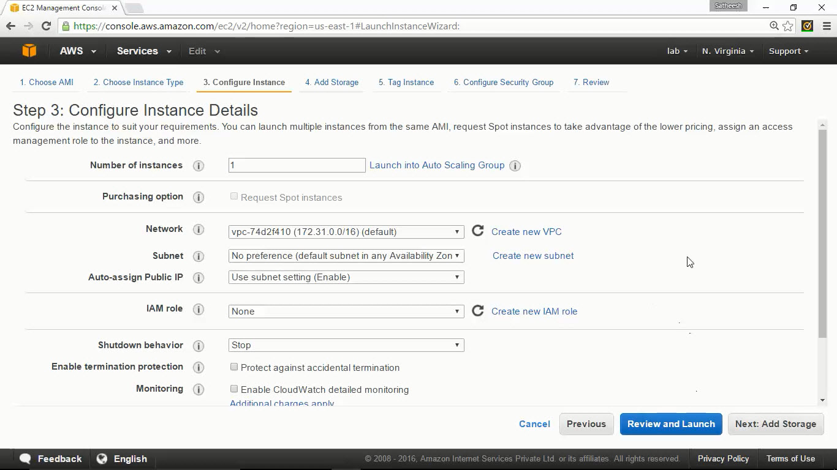

The instance can be created in any subnet or availability zone.

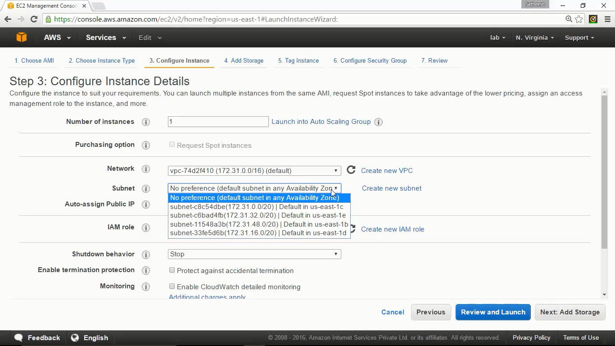

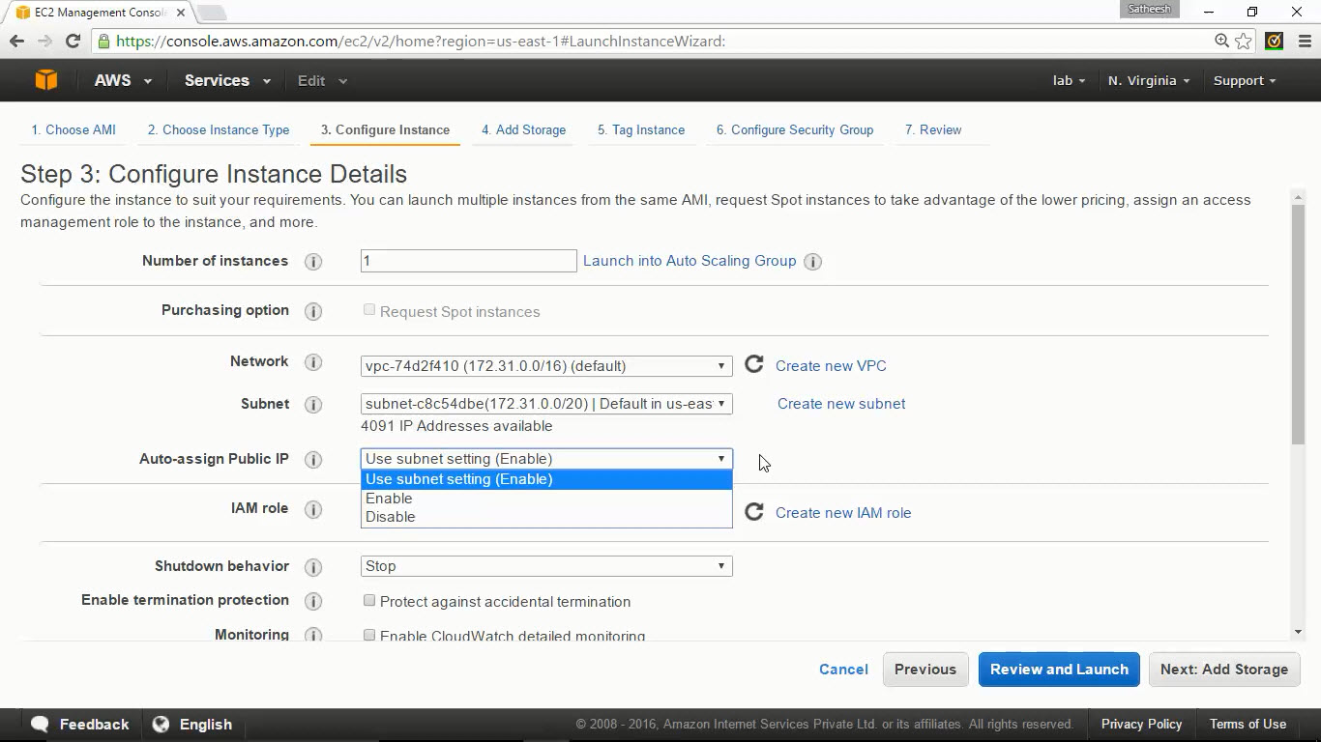

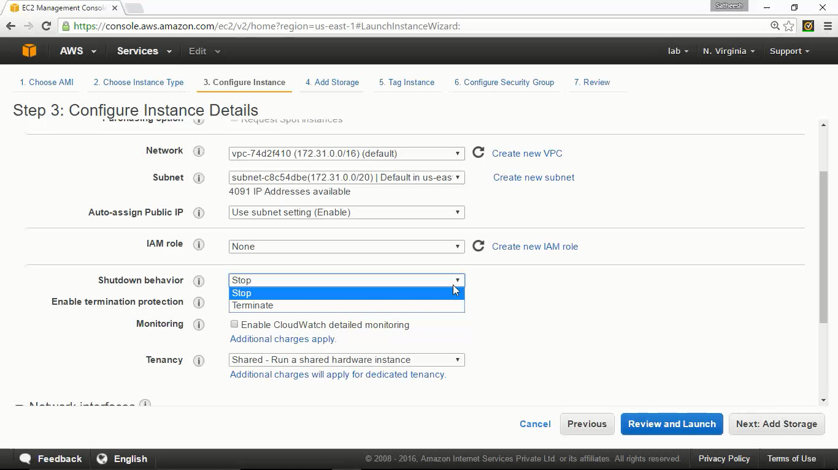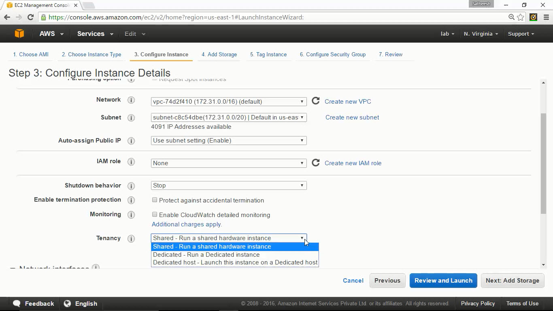

EC2 instances would have one elastic NIC by default. At maximum 2 NICs can be added to any instance. You can use “Add Device” option to attach the 2nd NIC from the Network interfaces option.

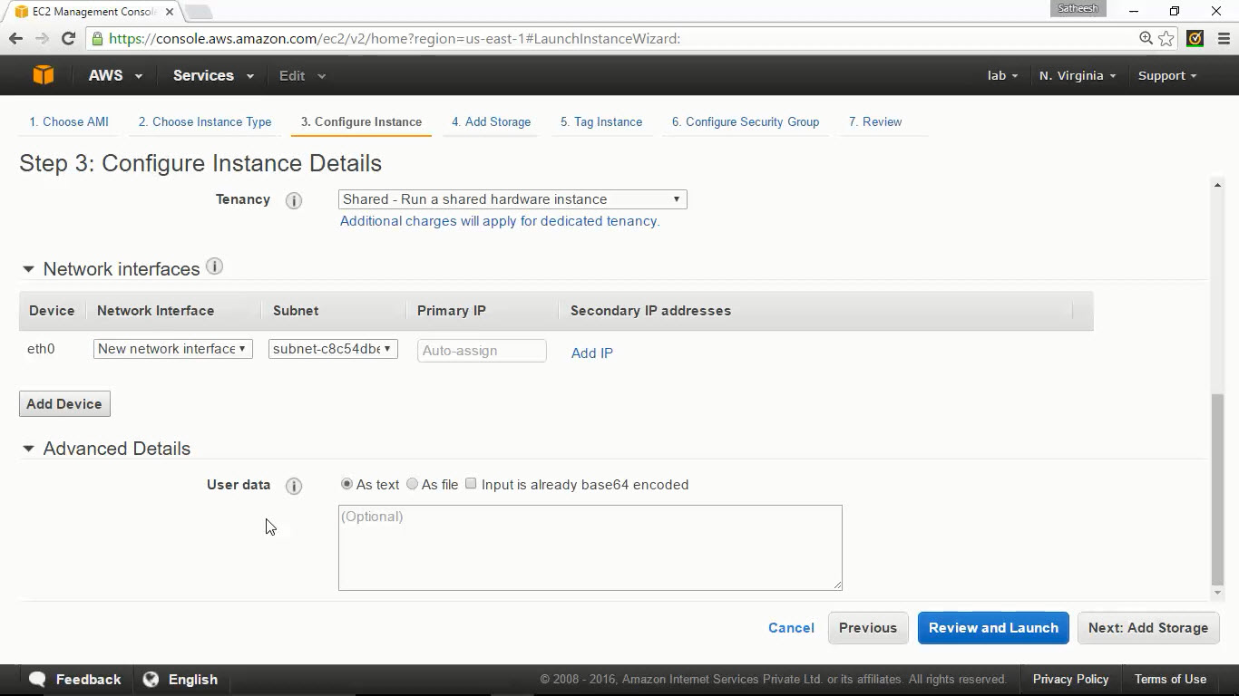

## Adding volumes

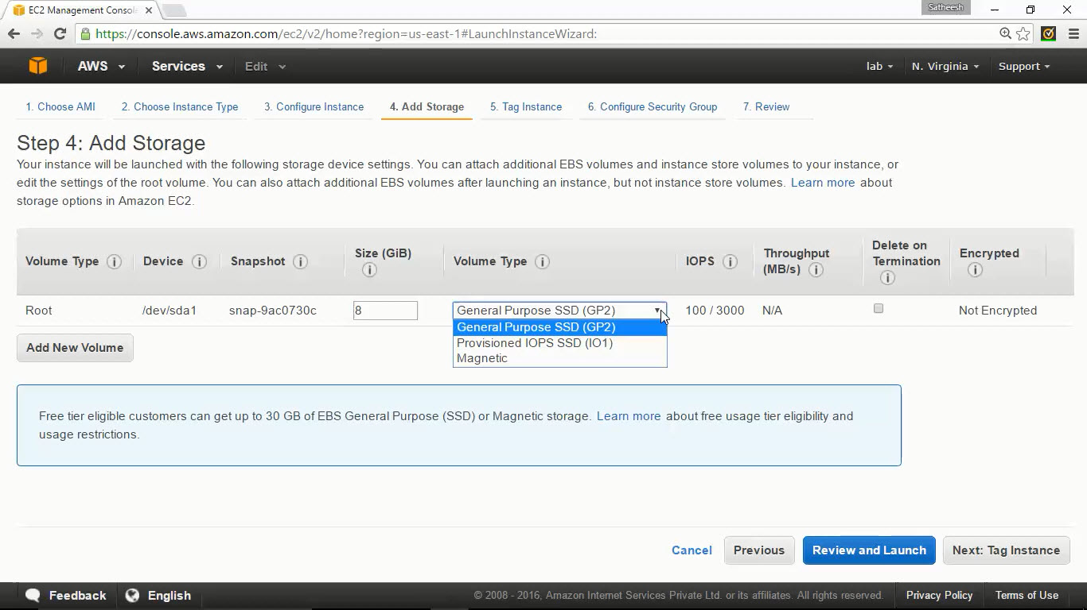

## Adding Tags

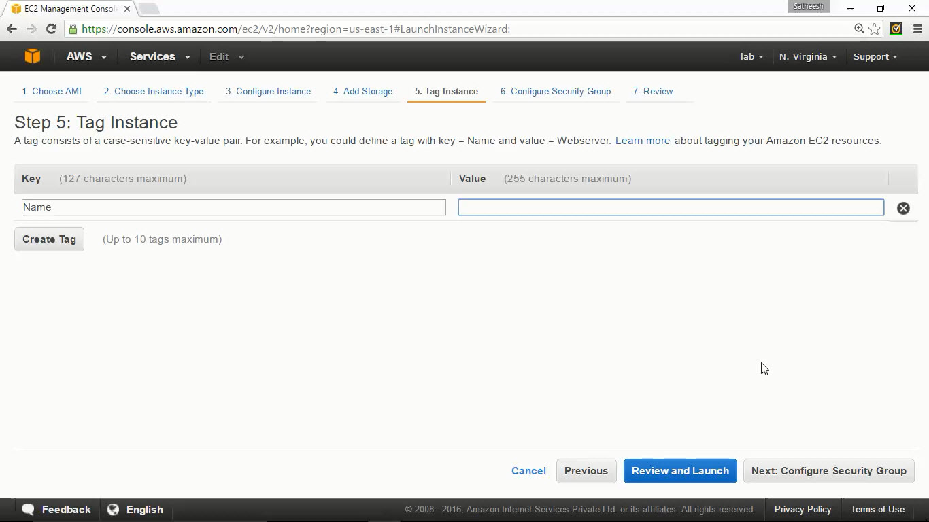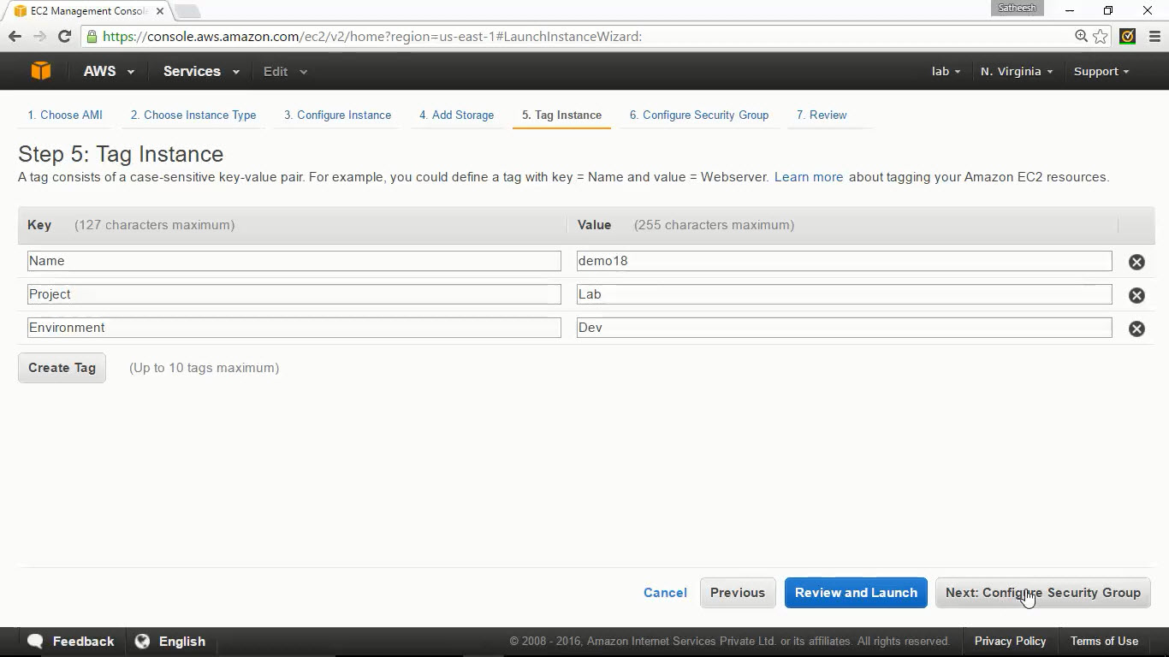

## Create security groups

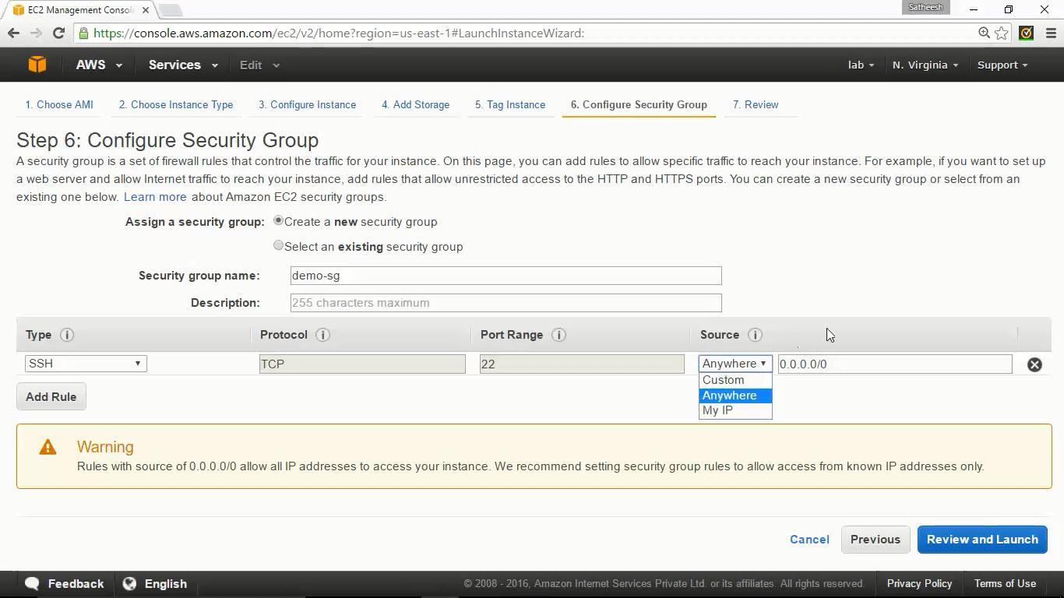

## Review

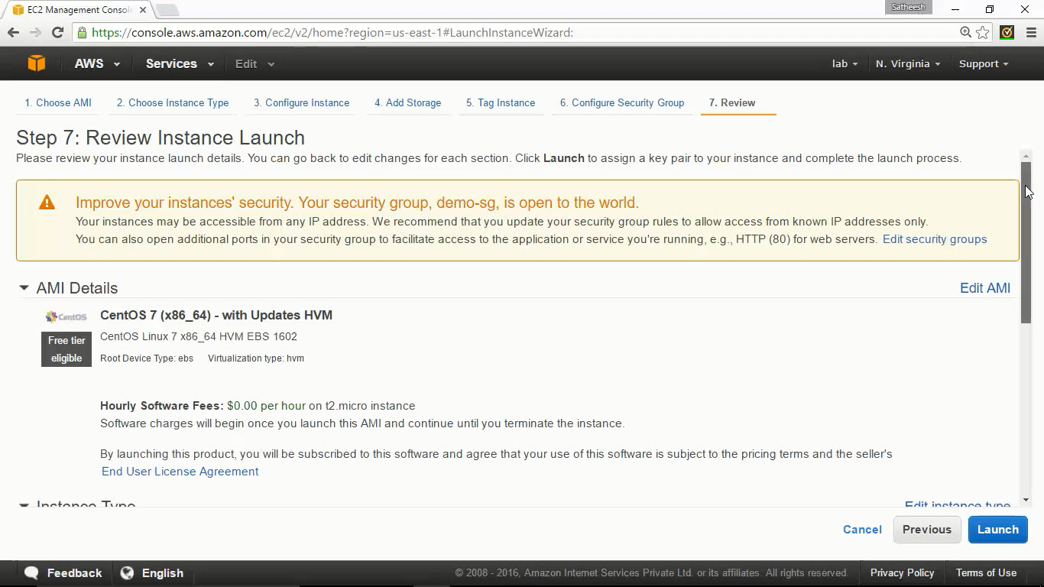

## Creating Keypair

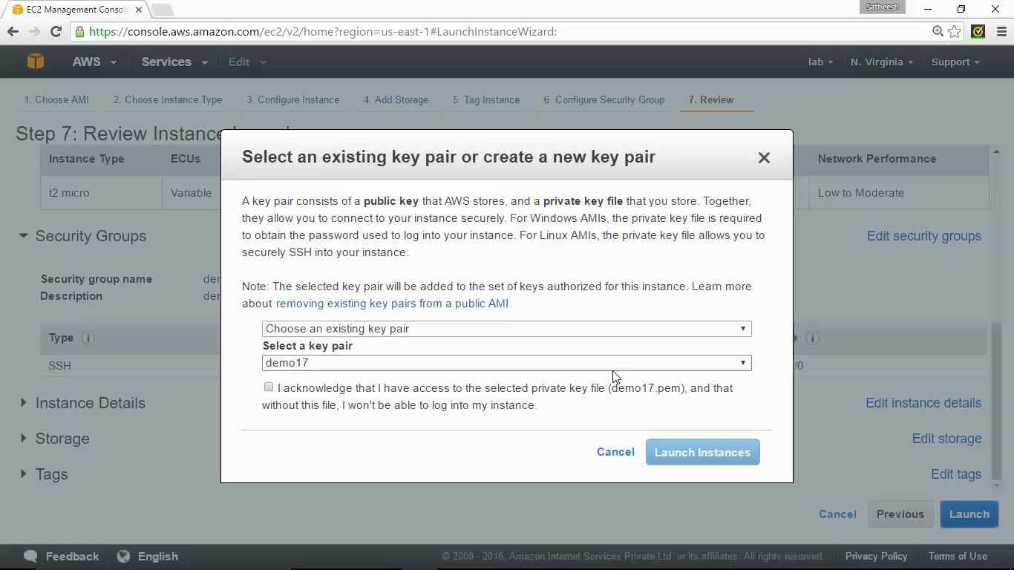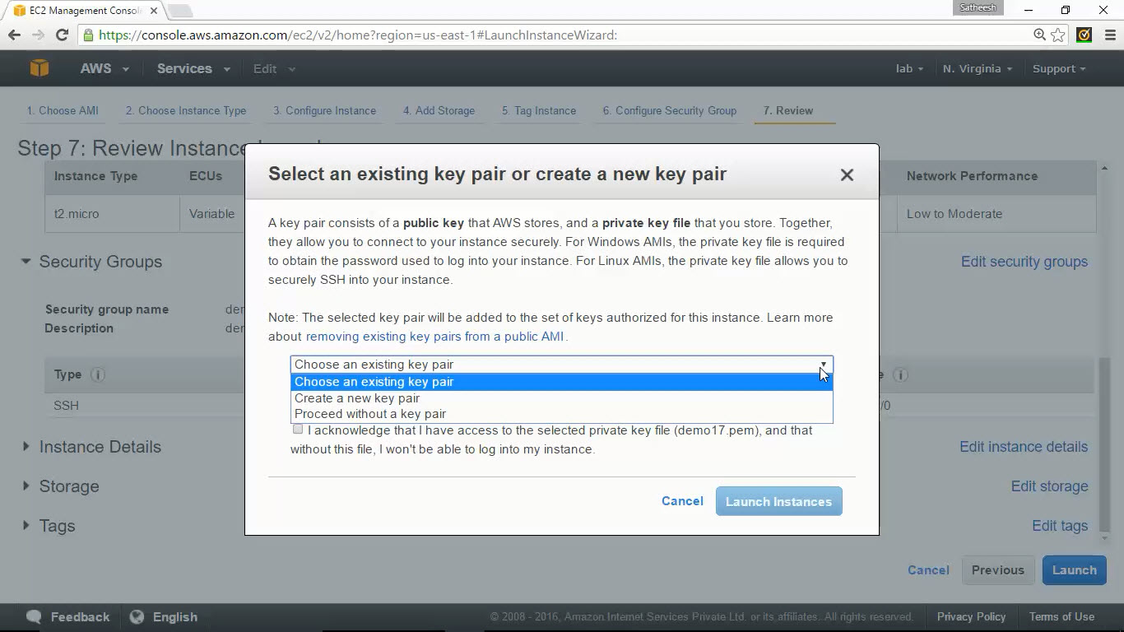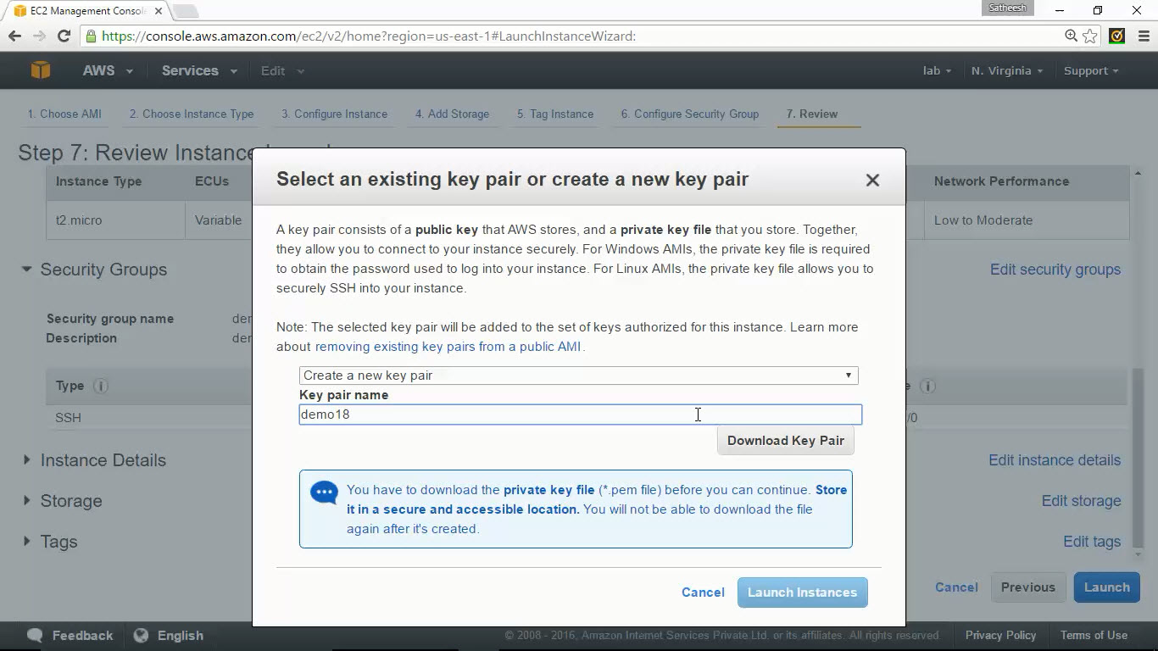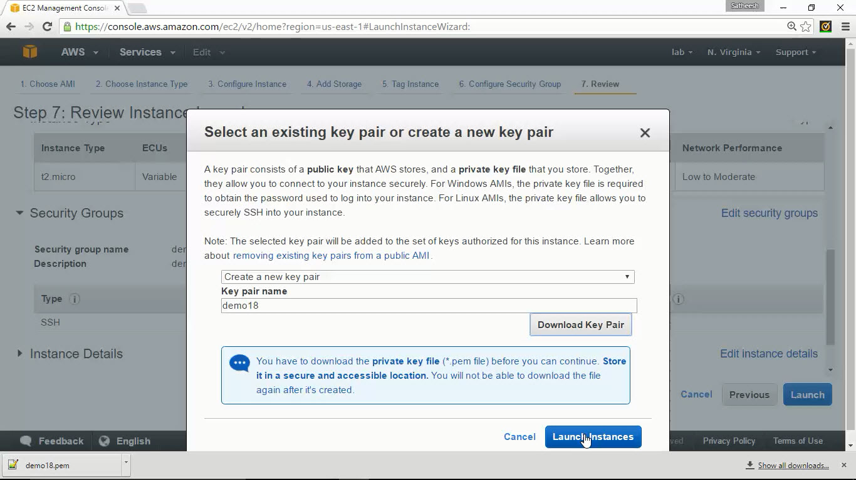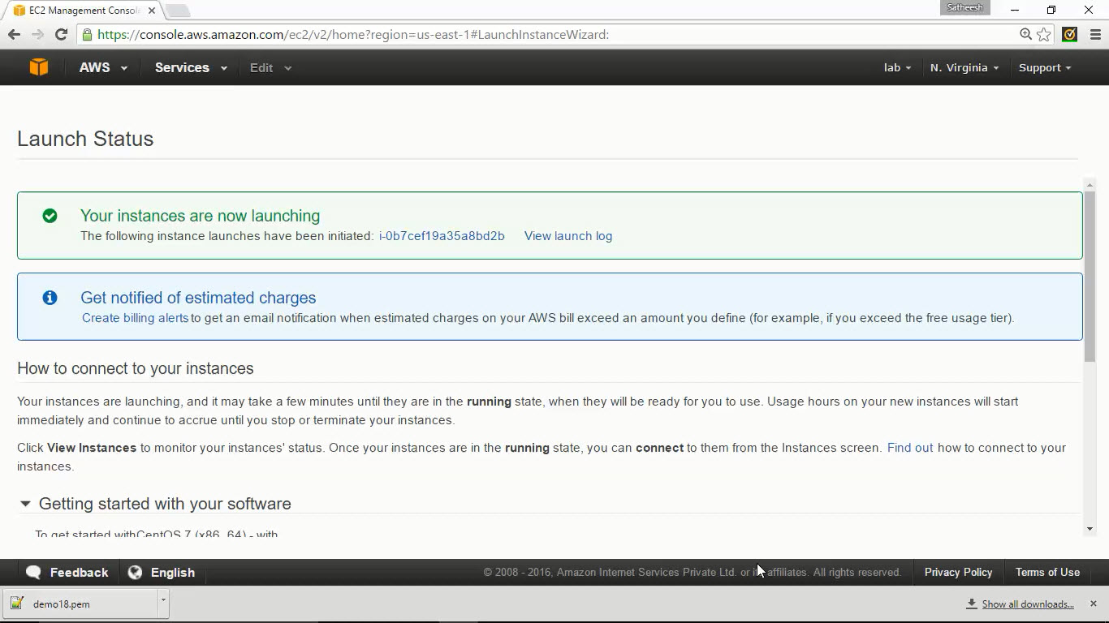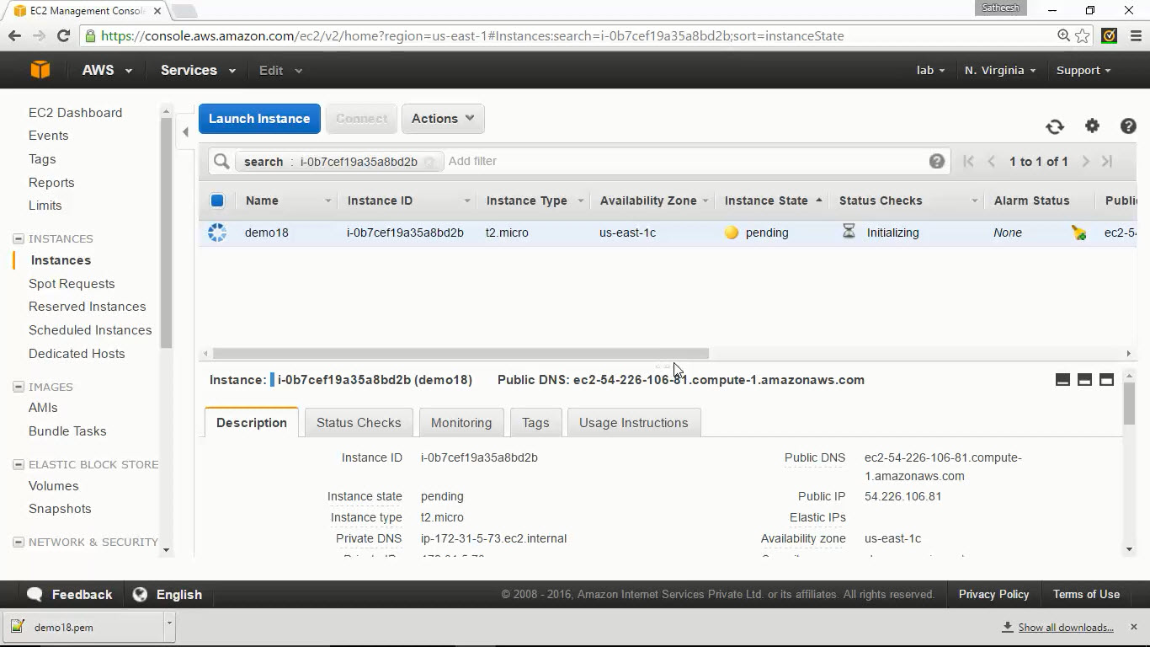

# EC2 metadata

## Description

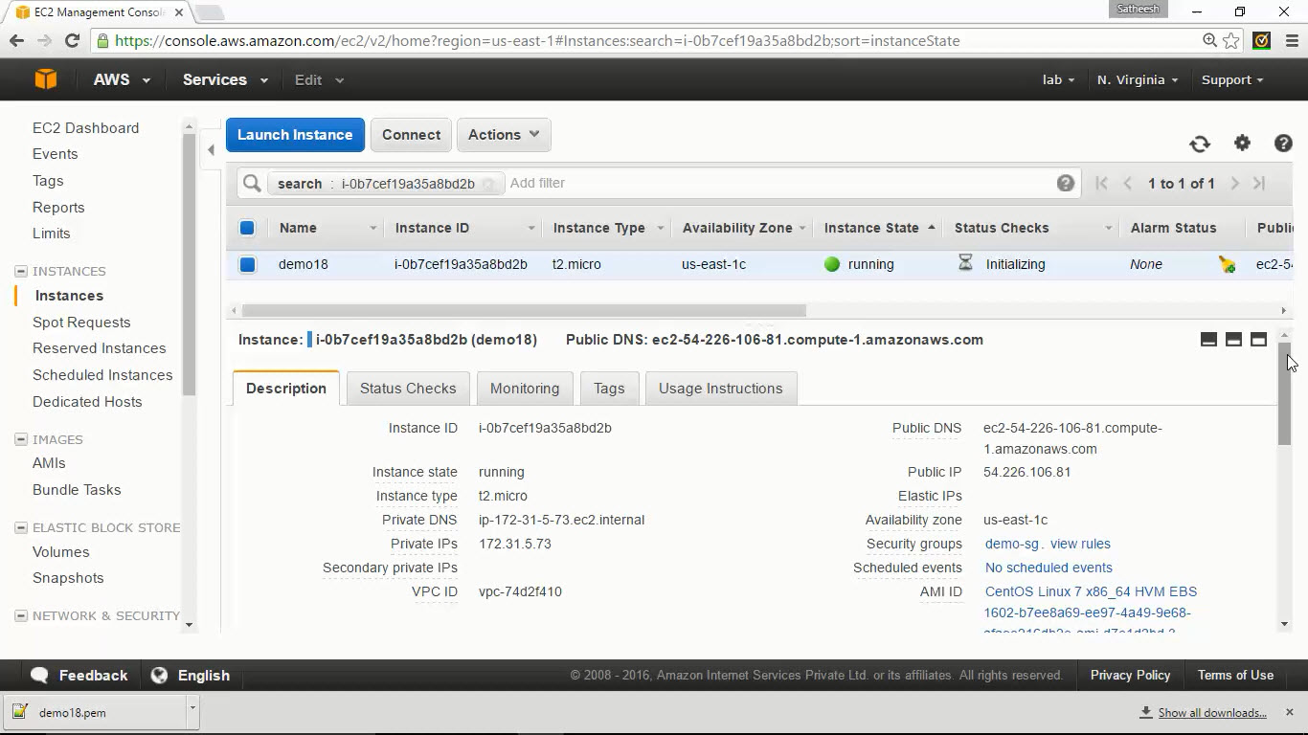

## Status Checks

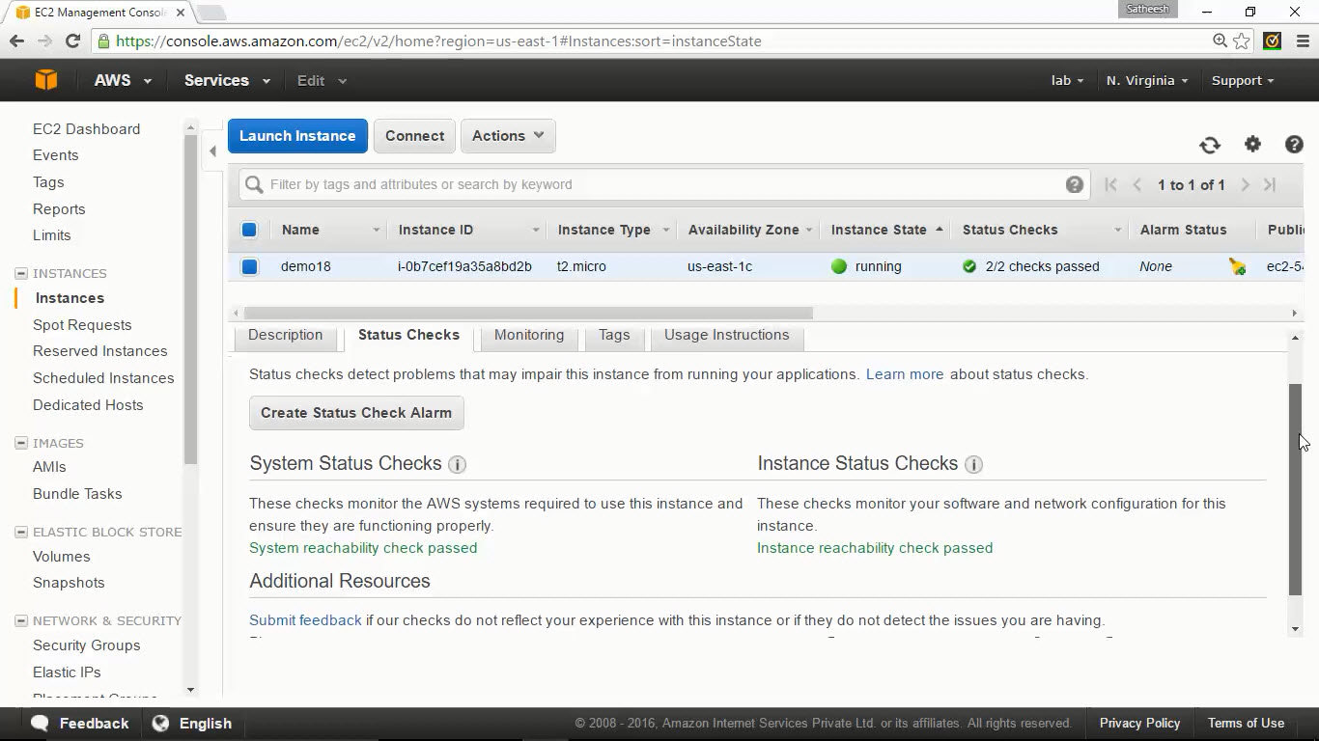

## Monitoring

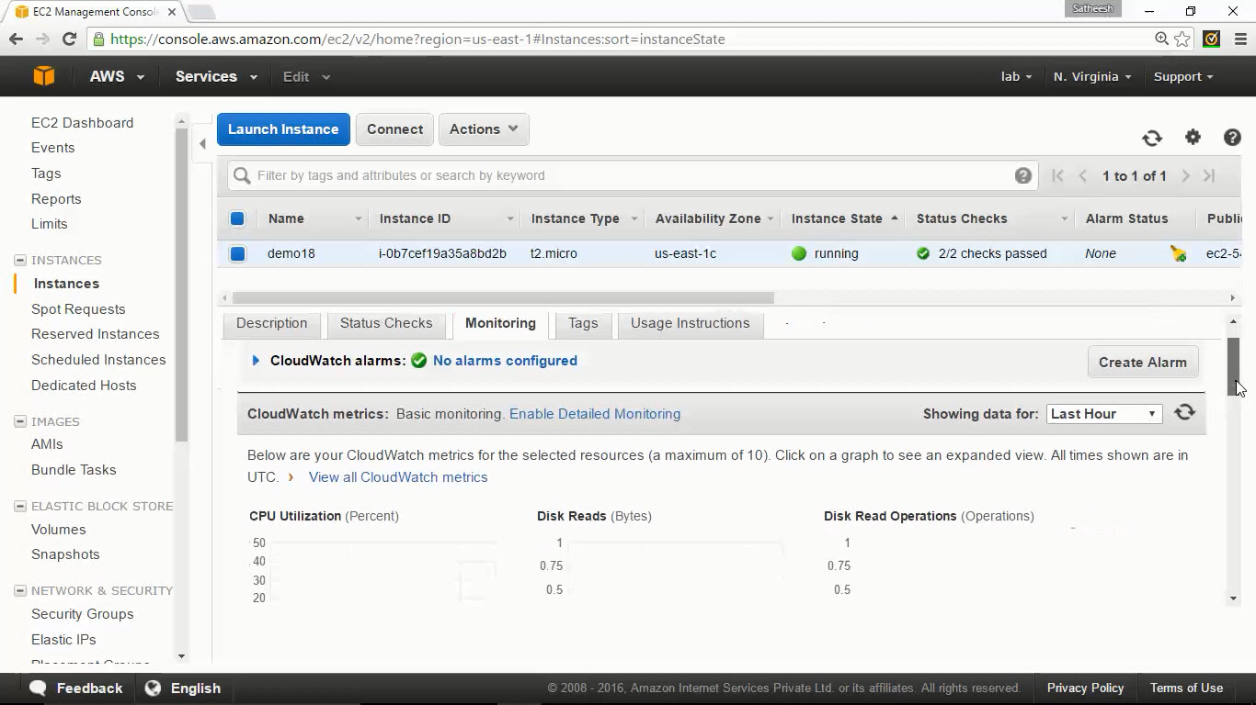

## Tags

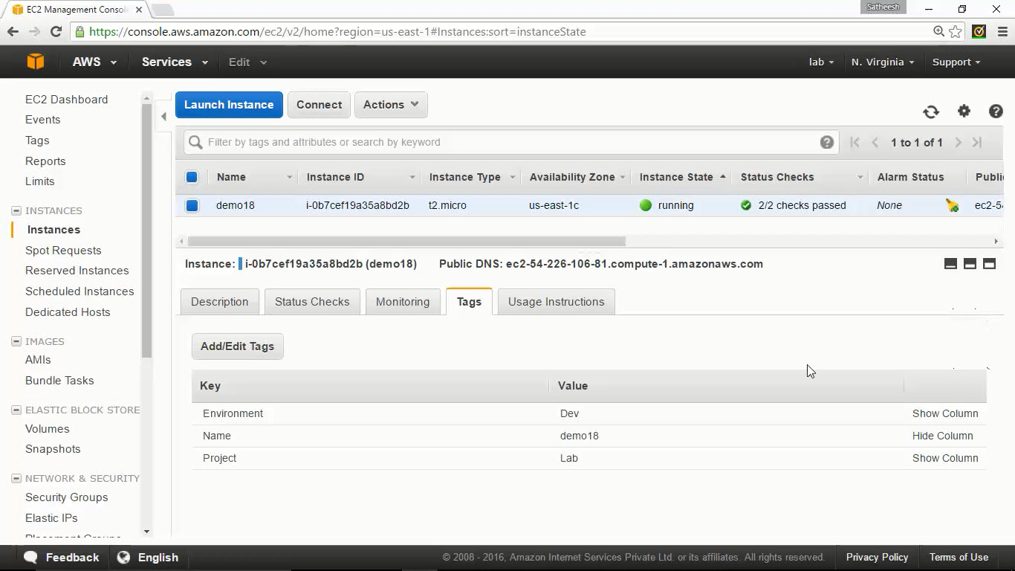

## Usage Instructions

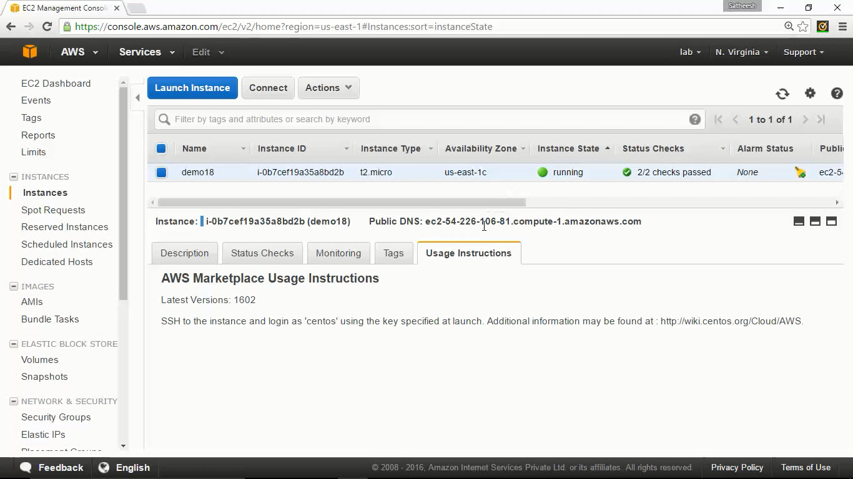

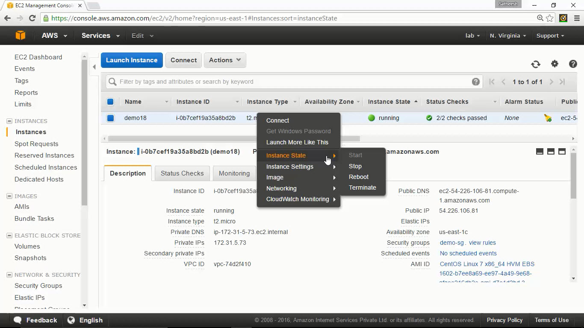

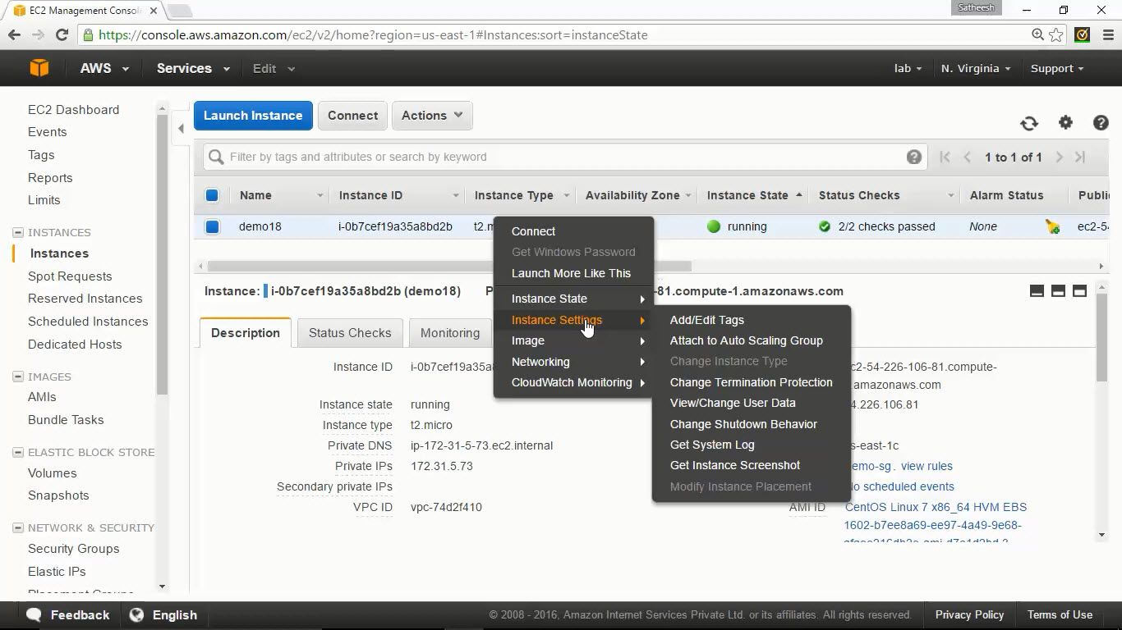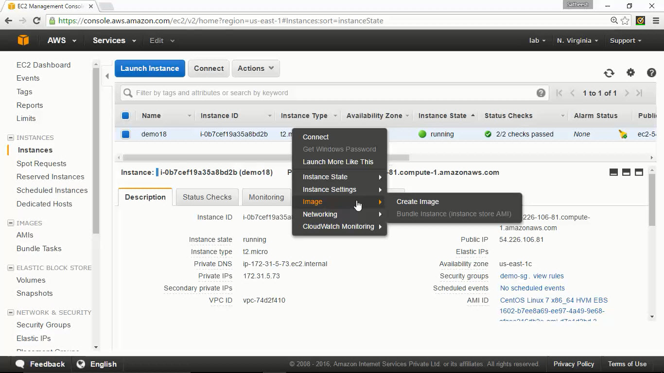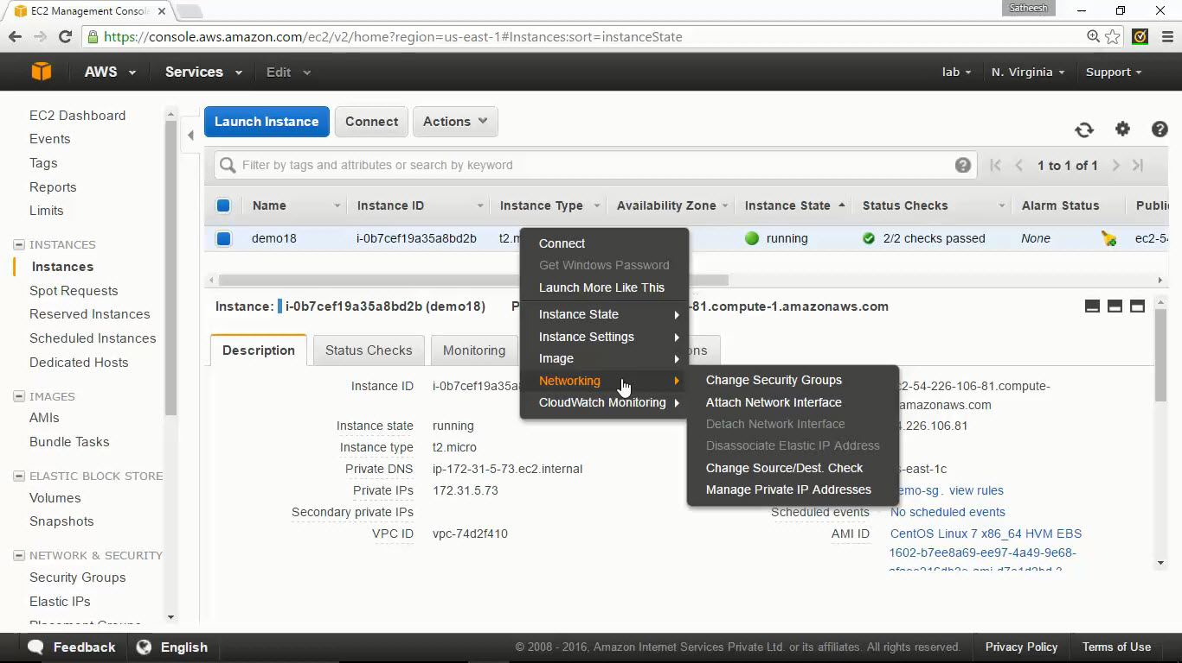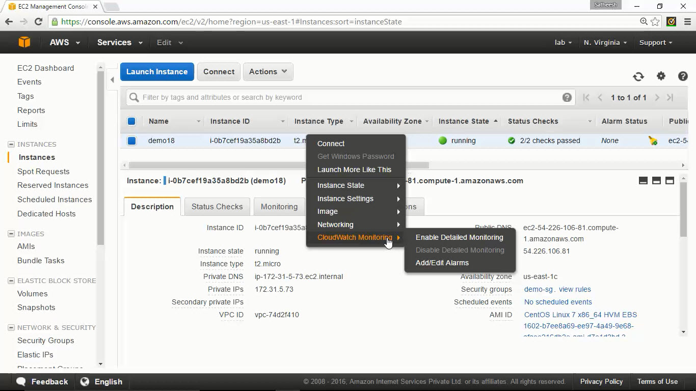

# Changing the size of EC2 instance



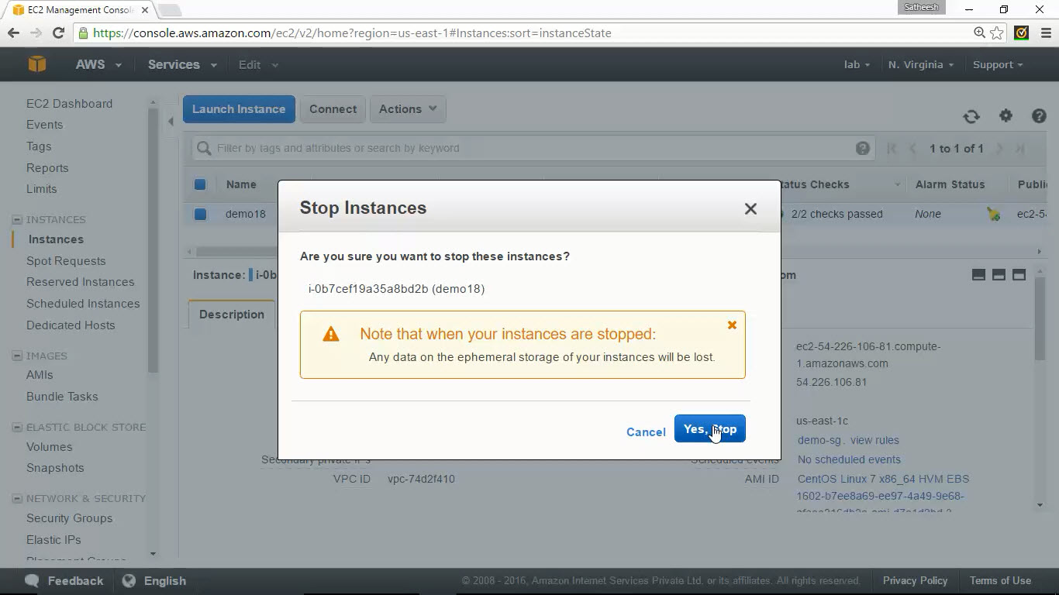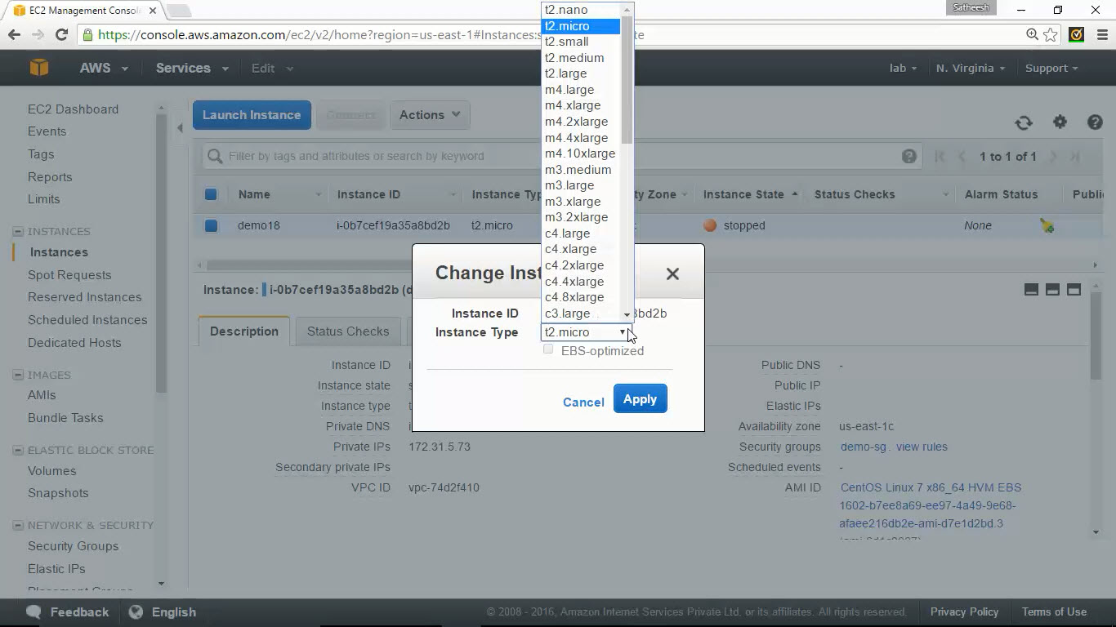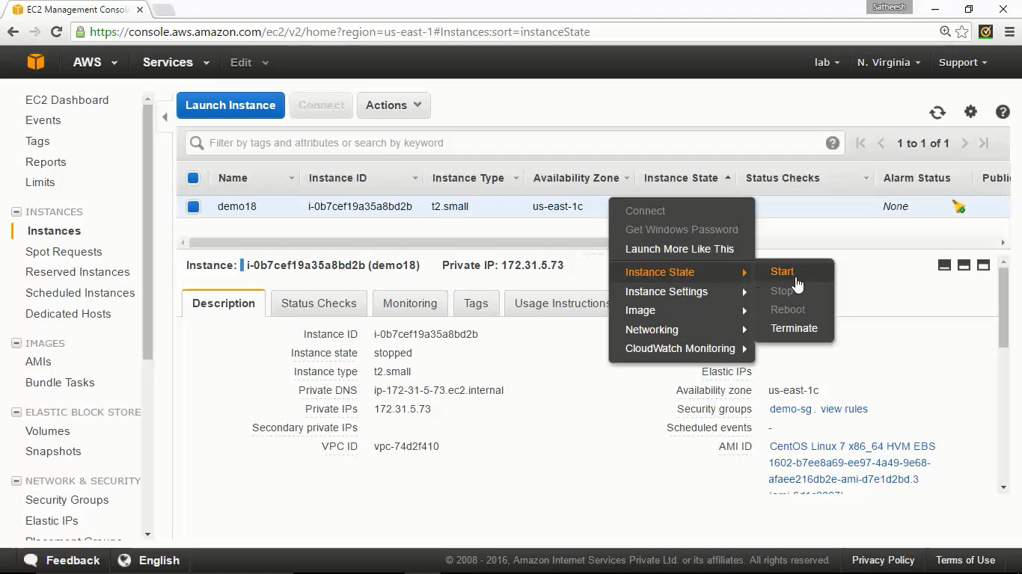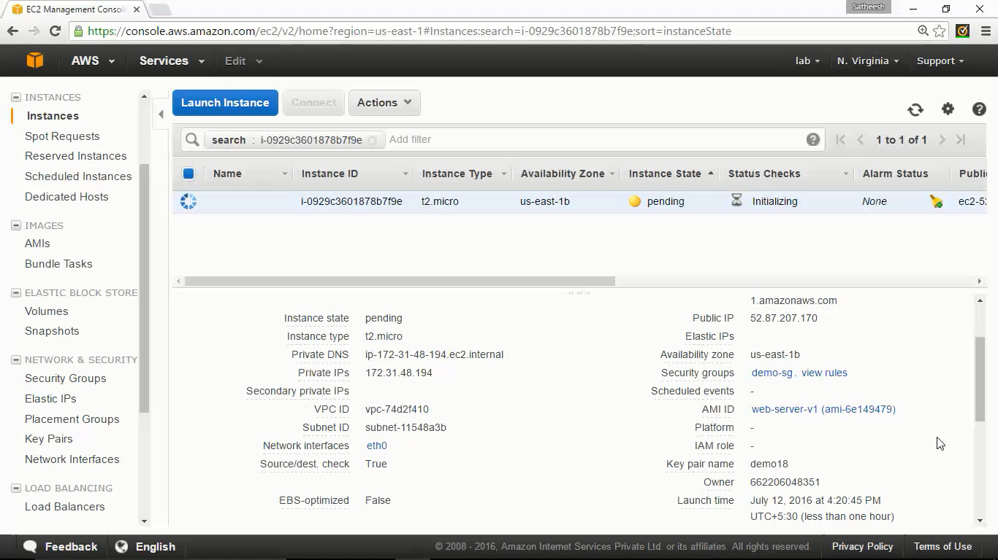

# Security groups

## Create new security group

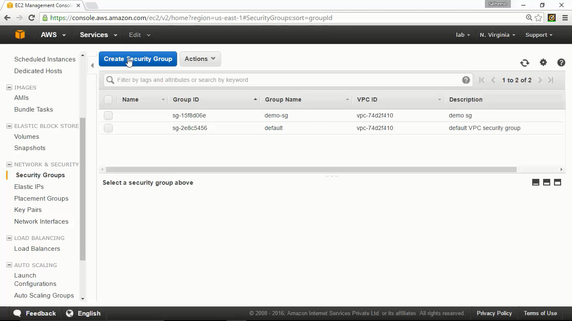

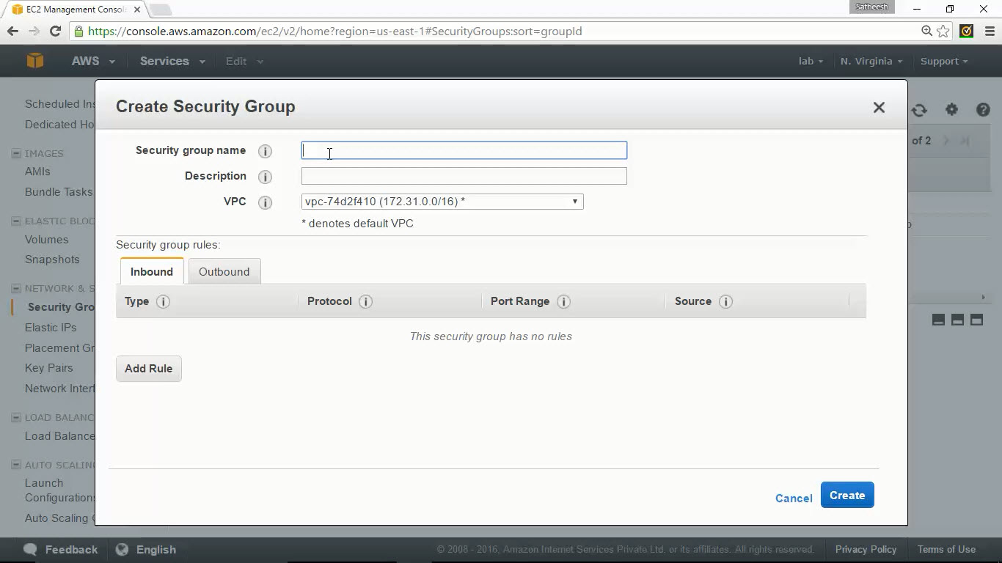

## Adding Rules

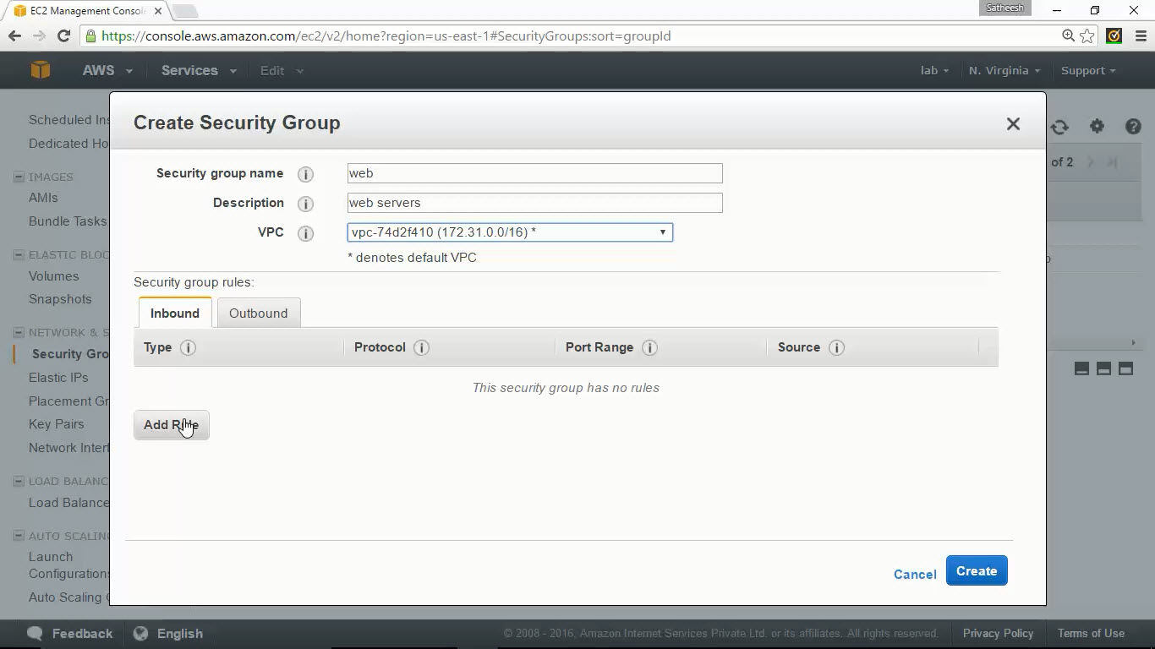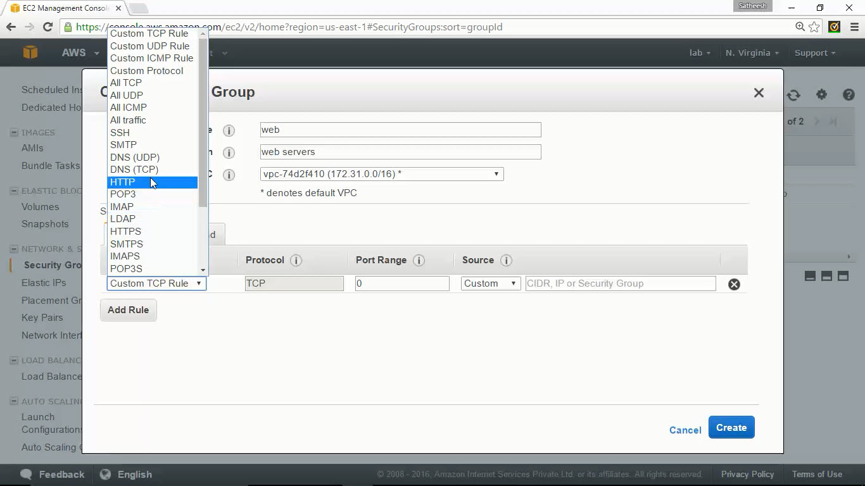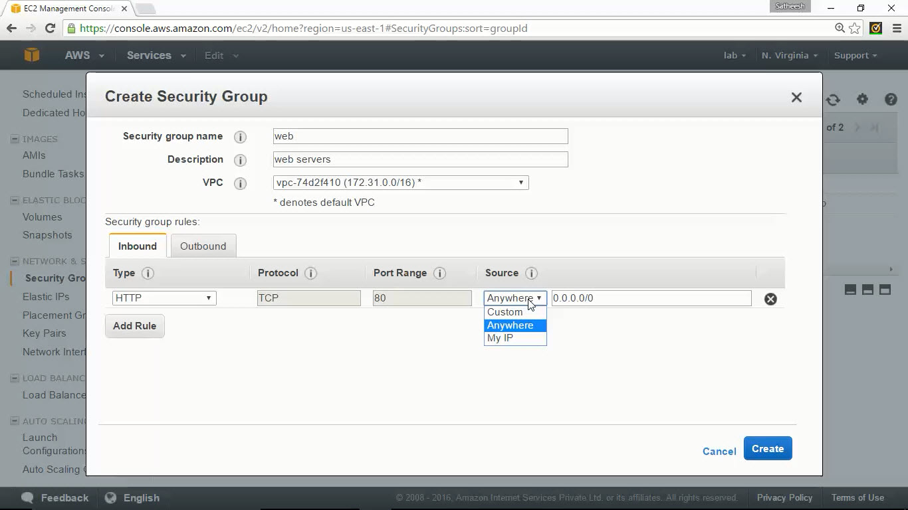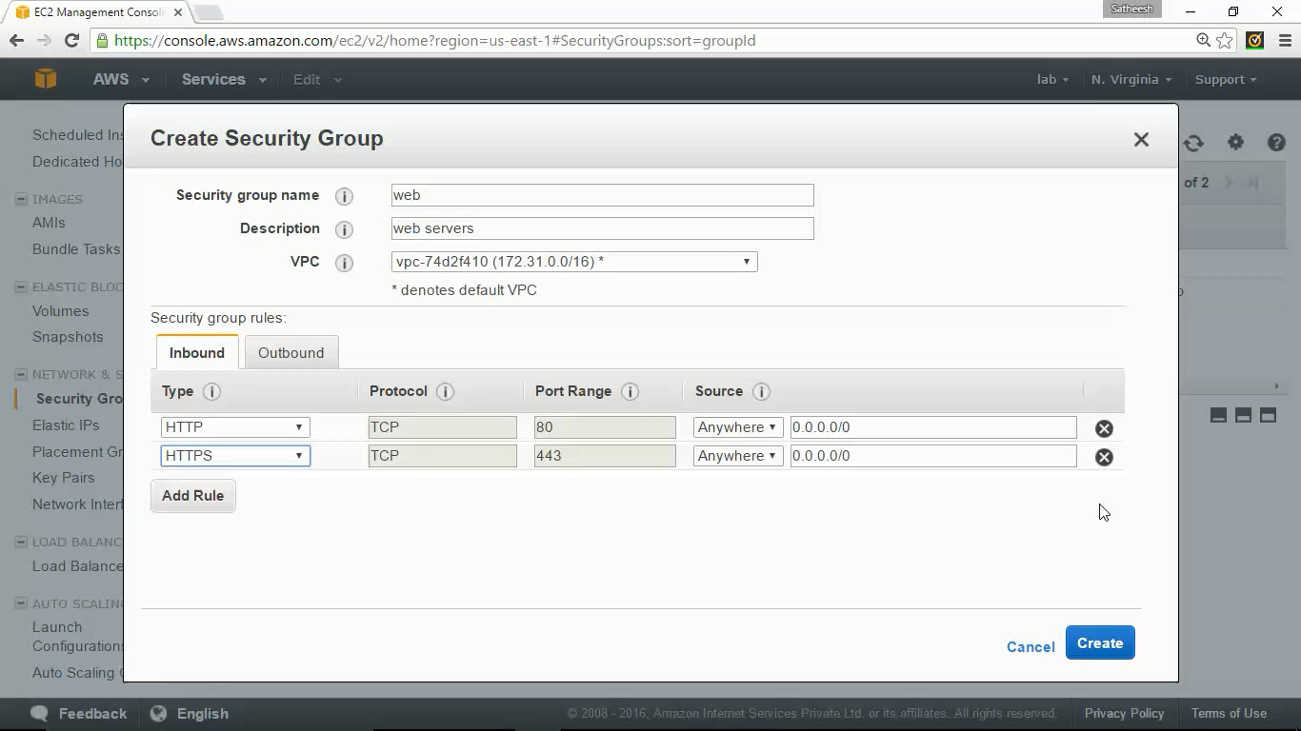

## Attaching security group to EC2



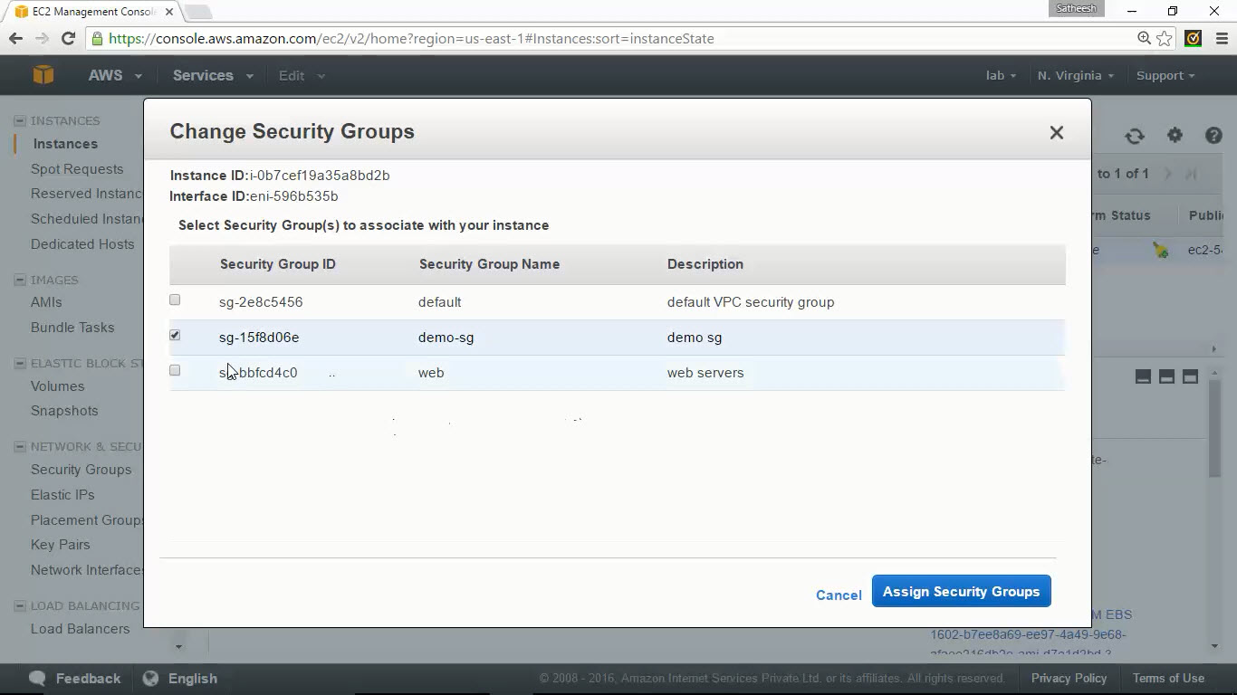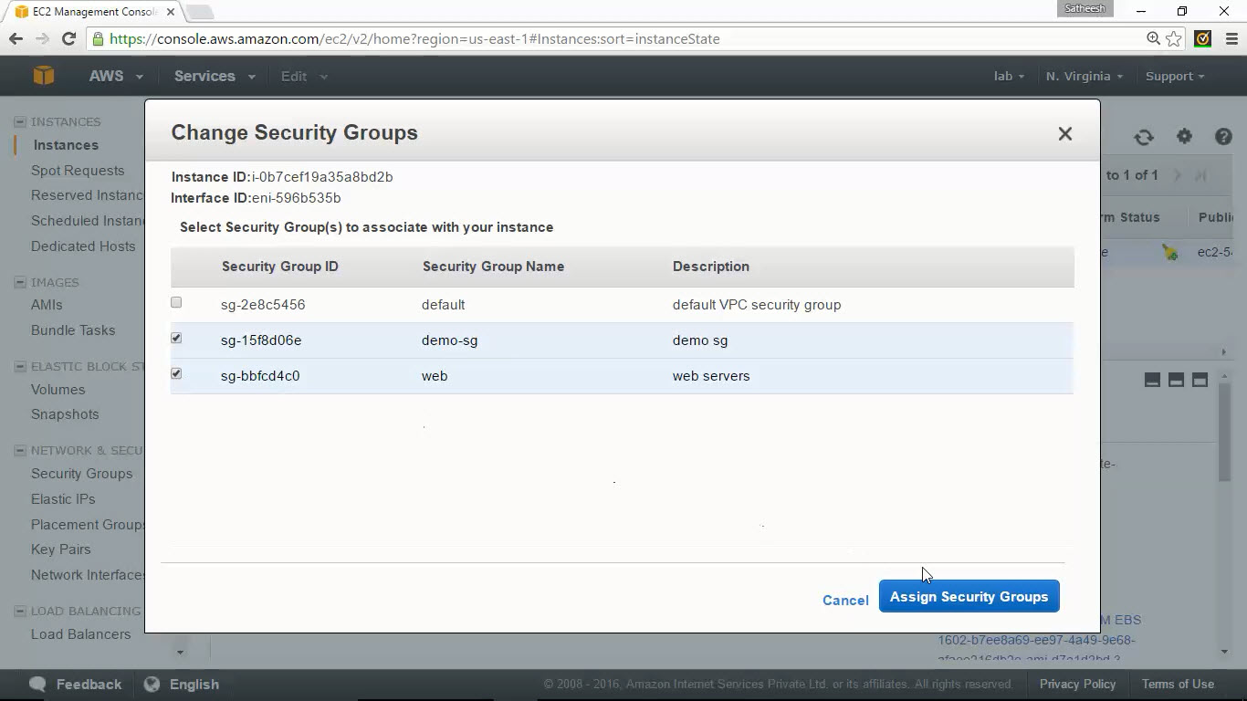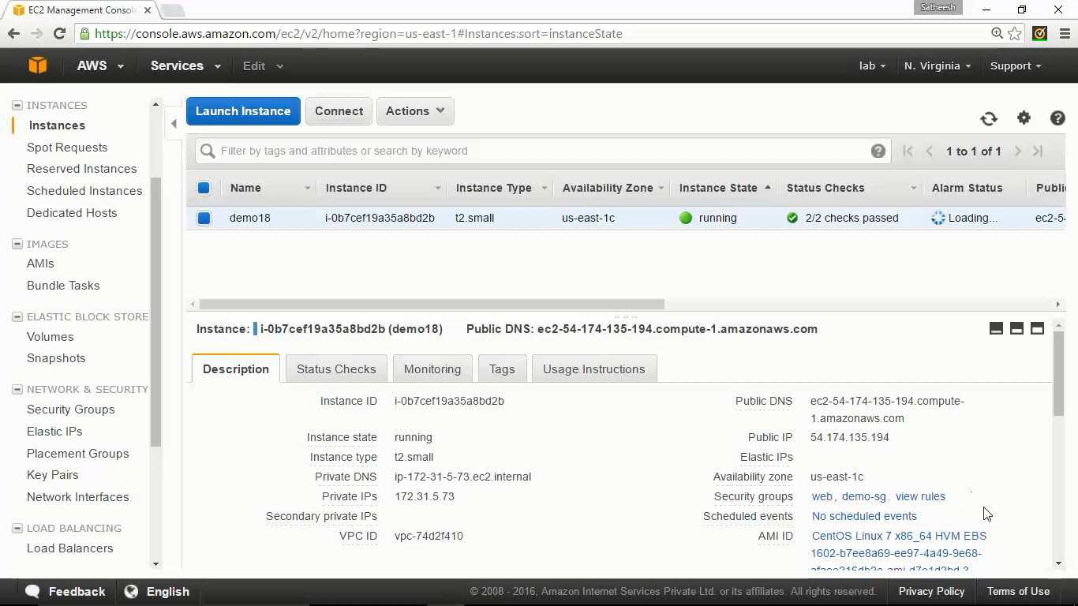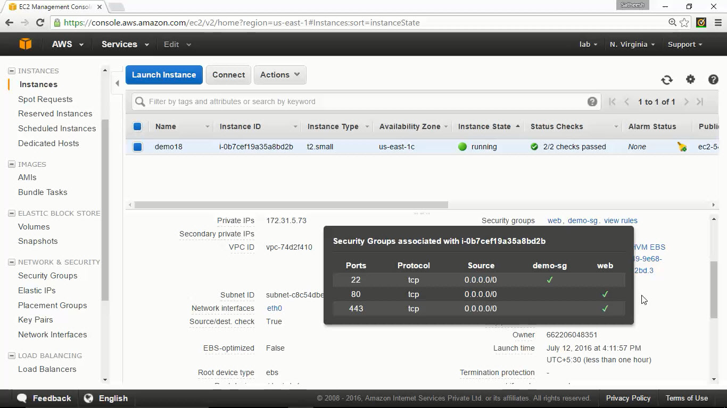

# Creating AMI



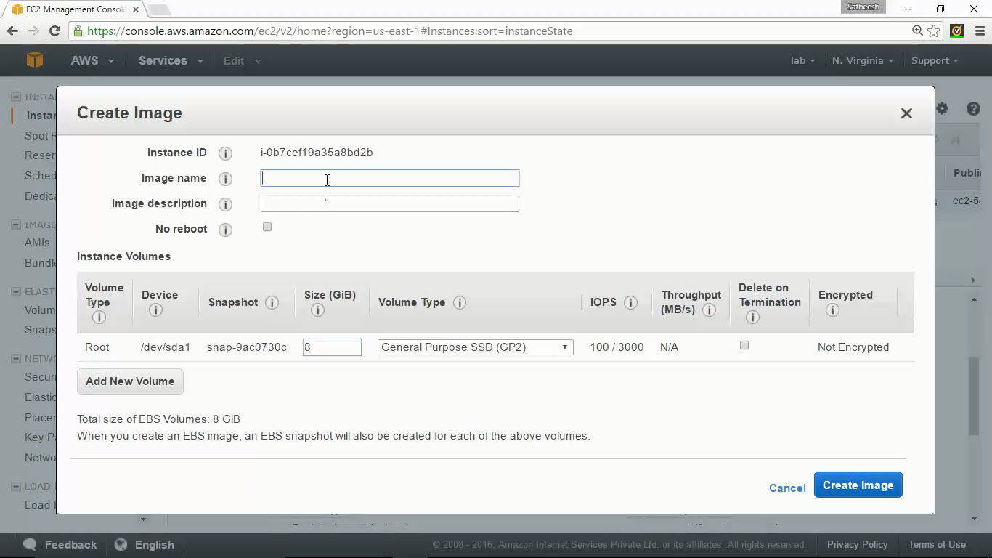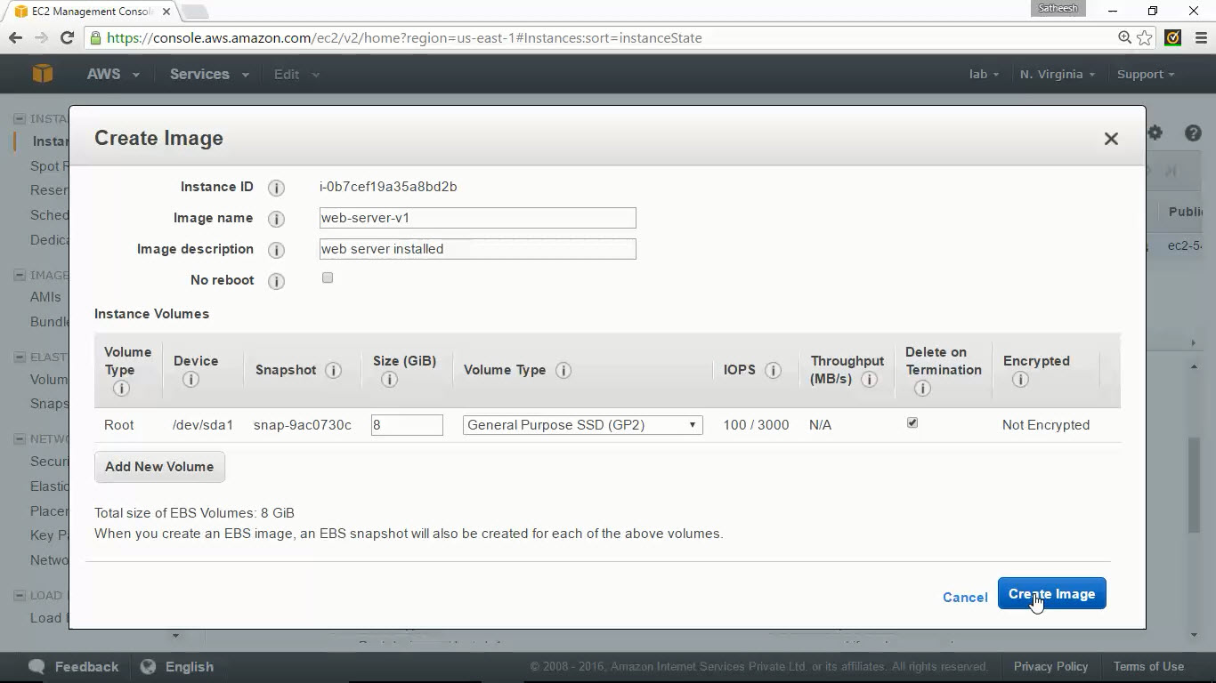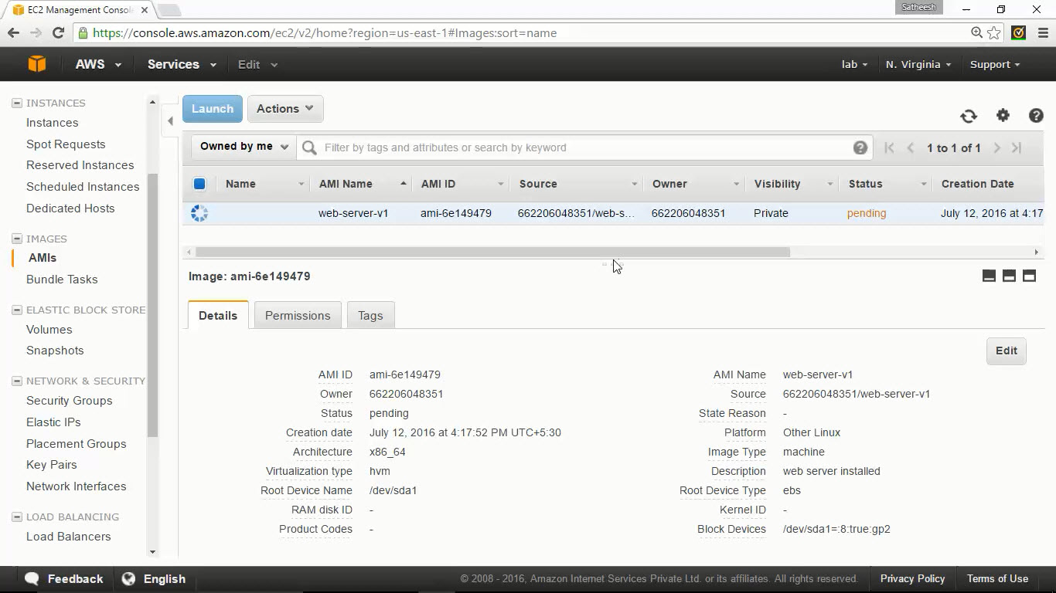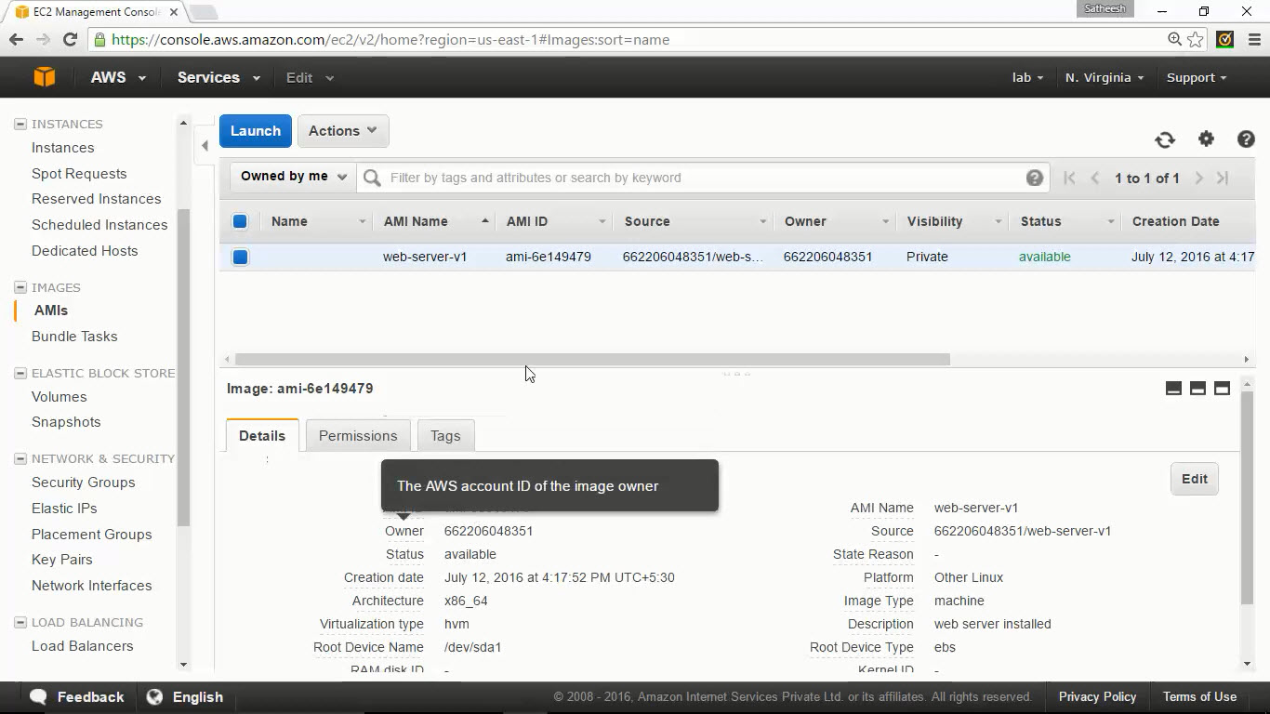

setenforce 0

vi /etc/sysconfig/selinux

SELINUX=enforcing change to SELINUX=disabled

yum install -y httpd

systemctl enable httpd

systemctl start httpd

echo "welcome page" > /var/www/html/index.html

--------

#!/bin/bash

setenforce 0

#SELINUX=enforcing change to SELINUX=disabled in /etc/sysconfig/selinux

sed -i -e 's/SELINUX=enforcing/SELINUX=disabled/' /etc/sysconfig/selinux

yum install -y httpd

systemctl enable httpd

systemctl start httpd

echo "welcome page" > /var/www/html/index.html

http://pkgs.repoforge.org/stress/stress-1.0.2-1.el7.rf.x86_64.rpm